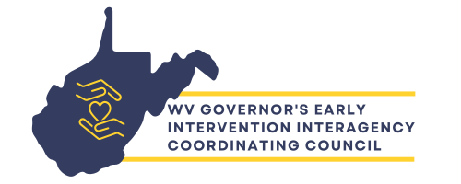
Agenda
January 21, 2026
Zoom

Time | Activity | Person(s) Responsible
9:30 am | Welcome and Introductions | Everyone
9:40 am | Lead Agency Update | WV Birth to Three State Team
11:15 am | WV GEIICC Committee Updates | Committee Chairs
11:45 am | Review of Minutes
12:10 pm | Other Business | Council Chairperson
12:15 pm | Public Comment  Public comments are an opportunity for guests to share  celebrations, recognize community accomplishments, and share comments or concerns, either verbally or in writing. Comments should be made in a constructive way and there should be no expectation of response at this meeting. Documentation of the public comment will be made in the minutes of this meeting. | Council Chairperson Guests
12:30 pm | Adjourn | Council Chairperson

Upcoming Meetings
March 18, 2026 – St. John XXIII Pastoral Center, Charleston, WV
June 10-11, 2026 – Strategic Planning Retreat – Pipestem Resort State Park

