PUBLIC NOTICE OF MEETING

The WV Governor’s Early Intervention Interagency Coordinating Council will meet for its next regular meeting:
Wednesday, January 21, 2026
Zoom

The meeting is scheduled to begin at 9:30 am and will end at 12:30 pm. The agenda for this meeting is posted on the ICC website – https://www.wveiicc.org/upcoming _events.

The Council, mandated by Part C of the Individuals with Disabilities Education Act (IDEA), is to advise and assist the WV Department of Health in the implementation of the WV Birth to Three System. Interested people are invited to attend. For anyone needing special accommodation, information, or agenda copies, please contact Sheila Zickefoose, Council Director, five days prior to the meeting to coordinate arrangements.

Sheila A. Zickefoose, MA
WVGEIICC Council Director
PO Box 2438
Buckhannon, WV 26201
304-972-9348
Email: szickefoose@rvcds.org
http://www.wveiicc.org

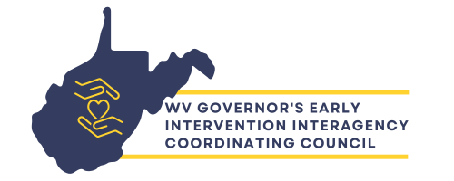
PO Box 2438, Buckhannon, WV 26201

304-972-9348

szickefoose@rvcds.org

https://www.wveiicc.org

